PSG COLLEGE OF TECHNOLOGY-COIMBATORE
DEPARTMENT OF APPLIED MATHEMATICS AND COMPUTATIONAL SCIENCES
III Sem MSc Software Systems - 18XW38 - RDBMS LAB
Problem Sheet – III

Create an employee table with attributes employee number, first name, last name, and designation, manager ID as MGR, date of birth, hire date, salary and commission. Enforce the following constraints on employee table:
Employee number is primary key, first and last names should not be null, Manager number will be the foreign key which refers primary of this table; date of birth must be less than or equal to 1980; Salary is less than Rs.1, 00,000/- and greater than Rs.20, 000/-.
CREATE TABLE `employee`(
ENO integer(3),
FNAME varchar(20) NOT NULL,
LNAME varchar(20) NOT NULL,
DESIG varchar(20),
MGR integer(3),
DOB date,
HDATE date,
SALARY decimal(7,2),
COMM decimal(7, 2),
PRIMARY KEY (ENO),
FOREIGN KEY (MGR) REFERENCES employee(ENO),
CONSTRAINT `yearcheck` CHECK(1980 >= YEAR(DOB)),
CONSTRAINT `salarycheck` CHECK (`Salary` < 100000 AND `Salary` > 20000)
);

ENO | FNAME | LNAME | DESIG | MGR | DOB | HDATE | SALARY Rs. | COMM. Rs.
101 | Janson | Hass | President |  | 12/09/1973 | 12/01/2003 | 87,500.00
110 | James | Thompson | Manager | 101 | 06/01/1973 | 25/02/2008 | 52,950.00
115 | Celia | Geyer | Manager | 101 | 07/09/1972 | 17/09/2007 | 46,850.00 | 22,530.00
117 | Robert | Stern | Manager | 101 | 04/02/1972 | 15/03/2006 | 49,900.00 | 20,555.00
135 | Linda | Pulaski | Salesman | 110 | 29/08/1968 | 19/09/2007 | 21,250.00 | 14,500.00
142 | David | Henderson | Salesman | 110 | 02/02/1970 | 23/03/2006 | 21,700.00 | 12,400.00
167 | Martin | Spenser | Salesman | 110 | 09/02/1971 | 28/07/2005 | 27,000.00 | 16,600.00
172 | Smith | Nicholls | Clerk | 110 | 12/03/1965 | 26/04/2003 | 21,850.00
154 | Larry | Adamson | Salesman | 110 | 02/02/1974 | 18/02/2004 | 22,250.00 | 17,000.00
179 | Mathews | Pinka | Analyst Manager | 117 | 08/01/1975 | 23/04/2008 | 35,000.00
183 | Sally | Brown | Clerk | 179 | 29/08/1968 | 14/07/2008 | 21,250.00
190 | Christine | Jones | Analyst Manager | 117 | 13/09/1968 | 05/09/2005 | 34,000.00
199 | Michael | Parker | Clerk | 190 | 07/02/1971 | 17/03/2004 | 21,600.00
200 | John | Mehta | Clerk | 115 | 02/03/1975 | 12/02/2006 | 21,350.00
137 | Bruce | Wong | Salesman | 110 | 12/12/1976 | 18/10/2005 | 22,250.00 | 13,000.00

INSERT INTO `employee`(`ENO`, `FNAME`, `LNAME`, `DESIG`, `MGR`, `DOB`, `HDATE`, `SALARY`, `COMM`) VALUES (101, 'Janson', 'Hass', 'President', null, '1973/09/12', '2003/01/12', 87500.00, null),
(110, 'James', 'Thompson', 'Manager', 101, '1973/01/06', '2008/02/25', 52950.00, null),
(115, 'Celia', 'Geyer', 'Manager', 101, '1972/09/07', '2007/09/17', 46850.00, 22530.00),
(117, 'Robert', 'Stern', 'Manager', 101, '1972/02/04', '2006/03/15', 49900.00, 20555.00),
(135, 'Linda', 'Pulaski', 'Salesman', 110, '1968/08/29', '2007/09/19', 21250.00, 14500.00),
(142, 'David', 'Henderson', 'Salesman', 110, '1970/02/02', '2006/03/23', 21700.00, 12400.00),
(167, 'Martin', 'Spenser', 'Salesman', 110, '1971/02/09', '2005/07/28', 27000.00, 16600.00),
(172, 'Smith', 'Nicholls', 'Clerk', 110, '1965/03/12', '2003/04/26', 21850.00, null),
(154, 'Larry', 'Adamson', 'Salesman', 110, '1974/02/02', '2004/02/18', 22250.00, 17000.00),
(179, 'Mathews', 'Pinka', 'Analyst Manager', 117, '1967/01/08', '2008/04/23', 35000.00, null),
(183, 'Sally', 'Brown', 'Clerk', 179, '1968/08/29', '2008/07/14', 21250.00, null),
(190, 'Christine', 'Jones', 'Analyst Manager', 117, '1968/09/13', '2005/09/05', 34000.00, null),
(199, 'Michael', 'Parker', 'Clerk', 190, '1971/02/07', '2004/03/17', 21600.00, null),
(200, 'John', 'Mehta', 'Clerk', 115, '1975/03/02', '2006/02/12', 21350.00, null),
(137, 'Bruce', 'Wong', 'Salesman', 110, '1976/12/12', '2005/10/18', 22250.00, 13000.00);

Write SQL queries for the following requirements.

- List the details of all the employees who are younger than the employee with employee number 167.
SELECT * FROM `employee` WHERE DOB < (SELECT DOB FROM employee WHERE ENO = 167);
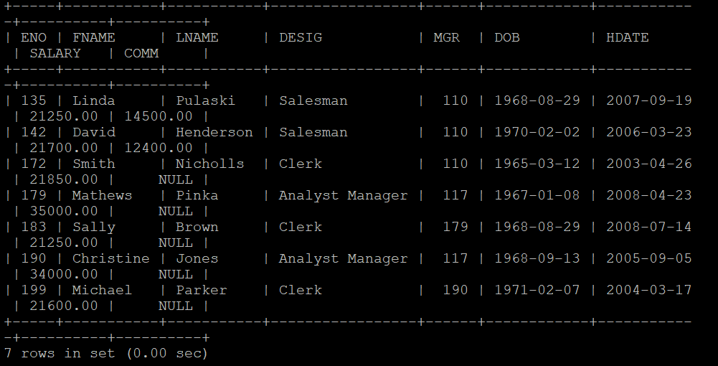
- Display first and last names all the employees who are less than 30 years old.
SELECT FNAME, LNAME FROM employee WHERE DATEDIFF(CURDATE(), DoB)/365 < 30;

- Display the details of employees whose last name contains the consecutive letters ‘er’.
SELECT * FROM `employee` WHERE LNAME LIKE '%er%';
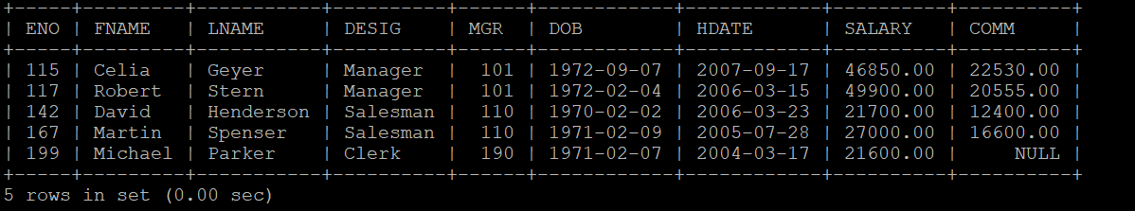
- Display the names of emplyees whose first name starts with ‘M’ or ‘J’.
SELECT FNAME, LNAME FROM employee WHERE FNAME LIKE 'M%' OR 'J%';
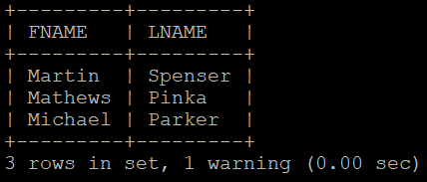
- Display first name, last name and salary of all the employees with the designation “Analyst Manager” or “Manager”.
SELECT FNAME, LNAME, SALARY FROM `employee` WHERE DESIG = 'Analyst Manager' or DESIG = 'Manager';
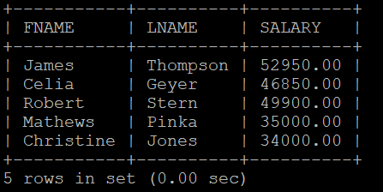
- Display the details of employee(s) who is (are) eldest in the employee table.
SELECT * FROM `employee` WHERE DOB = (SELECT MAX(DOB) FROM employee);
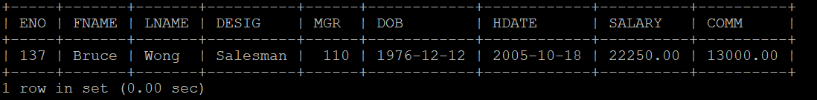
- List out the employees who all are not manager and analyst.
SELECT * FROM `employee` WHERE DESIG!='Manager' AND DESIG!='Analyst';
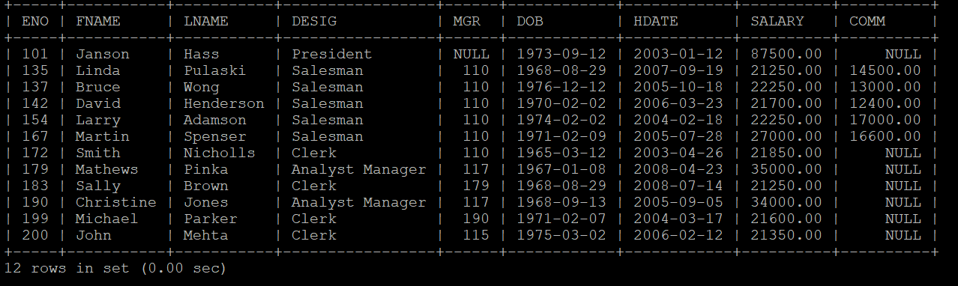
- Display the details of employees with a salary over Rs.35, 000.00 and born in between 1966 to 1976.
SELECT * FROM `employee` WHERE SALARY > 35000.00 AND DOB > 1966 and DOB < 1976;
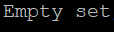
- Display the employee number, first name, last name, designation and salary whose salary is greater than or equal to Rs.35,000.00 and the job title is “Analyst” or “Manager”
SELECT `ENO`, `FNAME`, `LNAME`, `DESIG`, `SALARY` FROM `employee` WHERE SALARY >= 35000.00 AND (DESIG = 'Analyst' or DESIG = 'Manager');
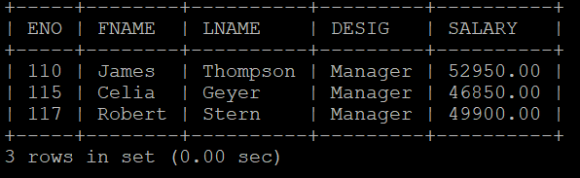
- Display the employee number, first name, last name, designation and salary of employees whose commission is greater than or equal to Rs.15,000.00 and designation is ‘Salesman’ or ‘Manager’.
SELECT `ENO`, `FNAME`, `LNAME`, `DESIG`, `SALARY` FROM `employee` WHERE COMM >= 15000.00 AND (DESIG = 'Salesman' or DESIG = 'Manager');
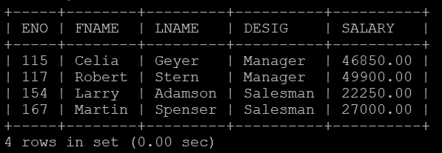
- Display the total number of employees in each job title/designation.
SELECT DESIG, COUNT(*) FROM employee GROUP BY DESIG;
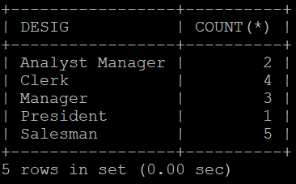
- Display the employee number, last name, Salary of employees whose last name is in the list, ‘Thompson’, ‘Spenser’, ‘Geyer’, and ’Brown’, ‘Jones’.
SELECT `ENO`, `LNAME`, `SALARY` FROM `employee` WHERE LNAME IN ('Thompson', 'Spenser', 'Geyer', 'Brown', 'Jones');
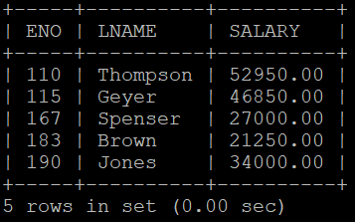
- Find out and display the total number of employees joined in every year.
SELECT YEAR(DOB), COUNT(*) FROM employee GROUP BY YEAR(DOB);
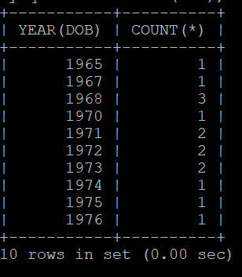
- Display the employee ID, last name, salary and age of employees whose age is in between 30 and 40.
SELECT `ENO`, `LNAME`, `SALARY`, DATEDIFF(CURDATE(), DoB)/365 FROM `employee` WHERE DATEDIFF(CURDATE(), DoB)/365 >= 30 AND DATEDIFF(CURDATE(), DoB)/365 <= 40;
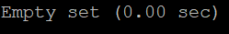
- Find out and display the first name employees who all are managed by ‘James’ or ‘Robert’ or ‘Celia’.
SELECT B.FNAME FROM employee A, employee B WHERE A.ENO = B.MGR AND A.FNAME IN ('James', 'Robert', 'Celia');
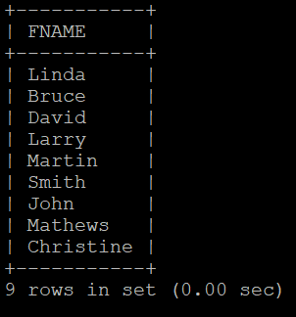
- Display all the employees with their fist name, last name and designation as follows
“First name“, “last name”, “designation”.
SELECT FNAME AS 'First Name', LNAME AS 'last Name', DESIG AS 'designation' FROM employee;
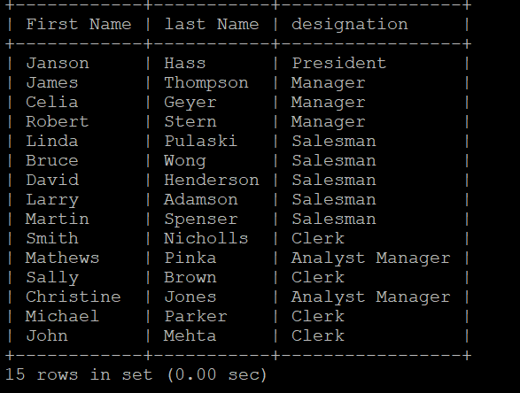
- Find out the employee who is youngest and has a commission.
SELECT * FROM employee WHERE COMM IS NOT NULL AND DOB = (SELECT MAX(DOB) FROM employee WHERE COMM IS NOT NULL);
OR
SELECT * FROM employee WHERE COMM IS NOT NULL ORDER BY DOB DESC LIMIT 1;
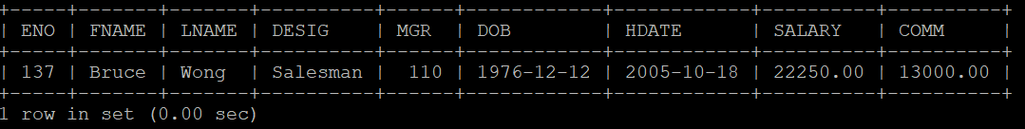
- Display all the employees with their date of birth and date of joining as follows.
Example: Dear ‘James ’, you were born on 06, Monday – September – 1972’.
SELECT 'Dear', "'", FNAME, "'", ",", "you were born on ", DAY(DOB), ", ", DAYNAME(DOB), "-", MONTHNAME(DOB), "-", YEAR(DOB), "'" FROM employee;
OR
SELECT 'Dear', CONCAT("'", FNAME, "'") AS NAME, ",", "you were born on ", DAY(DOB), ", ", DAYNAME(DOB), "-", MONTHNAME(DOB), "-", YEAR(DOB), "'" FROM employee;
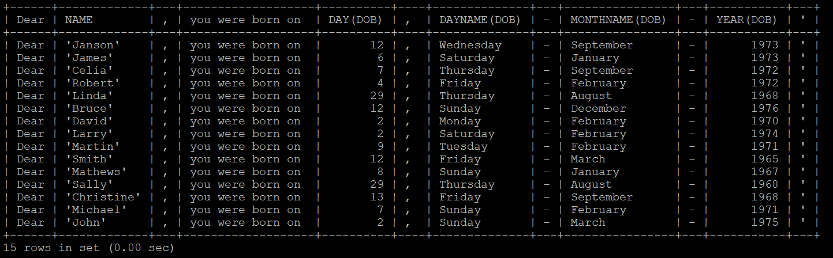
- Display the employees who are all getting maximum salary in each job title(designation).
SELECT * FROM employee WHERE (DESIG, SALARY) IN (SELECT DESIG, MAX(SALARY) FROM employee GROUP BY DESIG);
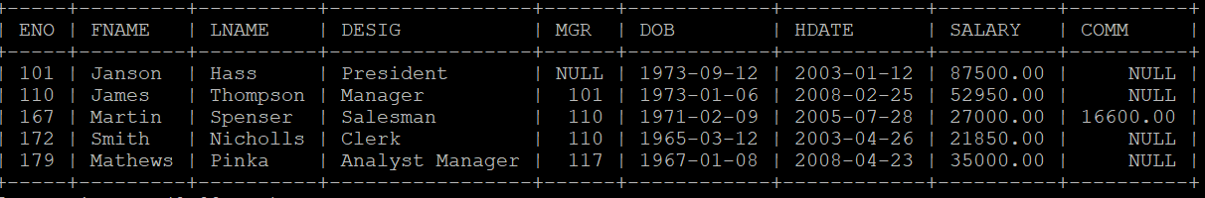
- Display the employee number, first name and salary of employees who were born in either January or February or August
SELECT ENO, FNAME, SALARY FROM employee WHERE MONTH(DOB) IN (01, 02, 08);
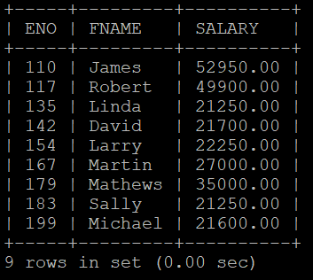
- Display the name, salary, commission and total remuneration (salary + commission) of all the employees.
SELECT FNAME, SALARY, COMM, (SALARY + IFNULL(COMM, 0)) AS "Total Remuneration" FROM employee;
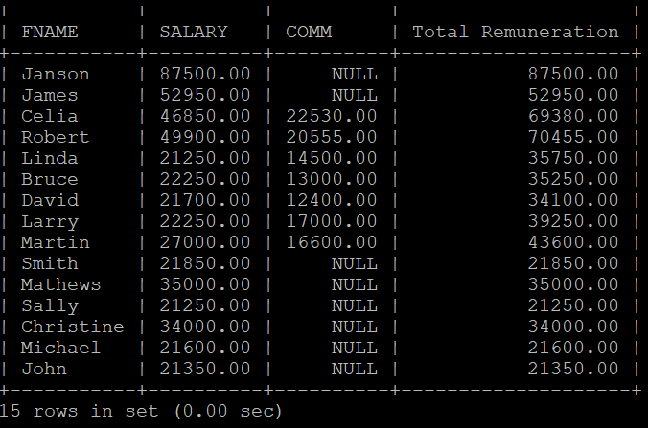
- Display the first name, salary, commission and total remuneration for all the employees and fill the column with 0 for those who do not have any commission in the commission column.
SELECT FNAME, SALARY, COMM, (SALARY + IFNULL(COMM, 0)) AS "Total Remuneration" FROM employee;
- Display first name of all the employees having maximum experience in each designation.
SELECT FNAME FROM employee WHERE (DESIG, DATEDIFF(CURDATE(), HDATE)) IN (SELECT DESIG, MAX(DATEDIFF(CURDATE(), HDATE)) FROM employee GROUP BY DESIG);
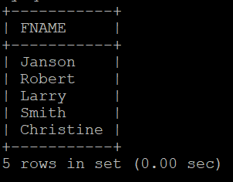
- Display the details of all the managers getting salary greater than Rs.40, 000.00 and born before 1973.
SELECT * FROM employee WHERE SALARY > 40000 AND DESIG = 'Manager' AND YEAR(DOB) < 1973;
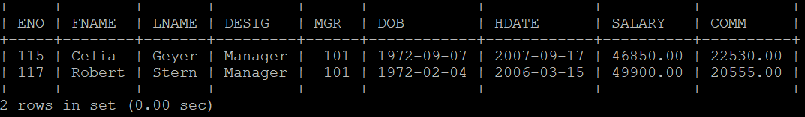
- Display all the details of employees who are not getting any commission but getting salary between Rs25,000.00 and Rs35,000.00.
SELECT * FROM `employee` WHERE COMM IS NULL AND SALARY > 25000.00 AND SALARY < 35000.00;
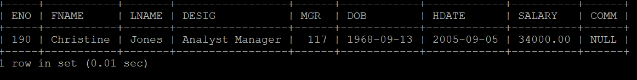
- Find and display the details of all the employees whose born and joined month are same.
SELECT * FROM `employee` WHERE MONTH(DOB) = MONTH(HDATE);
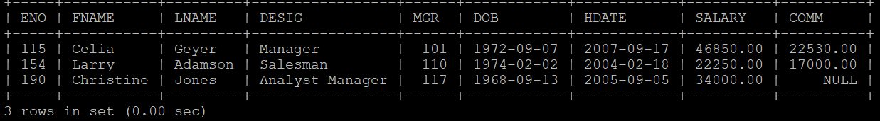
- Display the employee number and first name of all the employees with hire date in the format like February 22, 1991.
SELECT ENO, FNAME, DATE_FORMAT(HDATE, "%M %e, %Y") AS HDATE FROM employee;
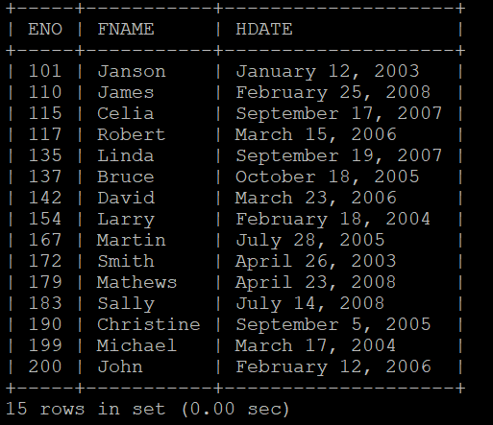
- Display the employee number, name, designation, hire date, and experience of all the managers.
SELECT ENO, FNAME, DESIG, HDATE, DATEDIFF(CURDATE(), HDATE)/365 AS "EXPERIENCE (IN YEARS)" FROM employee WHERE DESIG = 'Manager';
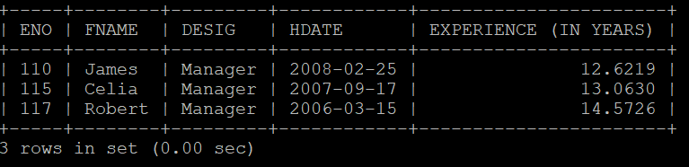
- List the employee ID, name, salary of all the 'Managers' and 'Analyst' with more than 5 years of experience and not receiving any commission. Display the list in ascending order of the employee number.
SELECT ENO, FNAME, LNAME, SALARY FROM employee WHERE DESIG IN ('Manager', 'Analyst') AND DATEDIFF(CURDATE(), HDATE)/365 > 5 AND COMM IS NULL ORDER BY ENO;
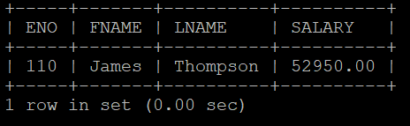
- List the employees who are senior to ‘Martin’.
SELECT * FROM `employee` WHERE DATEDIFF(CURDATE(), HDATE) > (SELECT DATEDIFF(CURDATE(), HDATE) FROM employee WHERE FNAME = 'Martin');
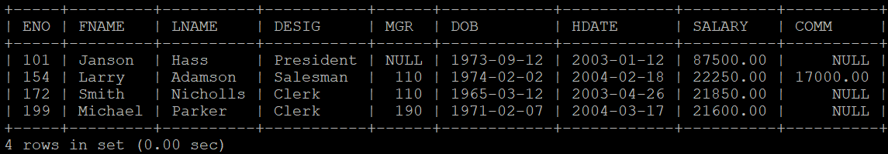
- Display the first names of all the employees whose salary is same as the salary of ‘Larry’.
SELECT FNAME FROM employee WHERE SALARY = (SELECT SALARY FROM employee WHERE FNAME = 'Larry');
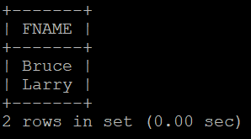
- Display the names of employees whose designation is same as the designation of ‘James’ or salary is more than the salary of ‘Celia’.
SELECT FNAME FROM employee WHERE DESIG = (SELECT DESIG FROM employee WHERE FNAME = 'James') OR SALARY > (SELECT SALARY FROM employee WHERE FNAME = 'Celia');
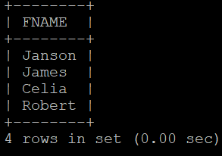
- Find and display the details of the highest paid employee(s).
SELECT * FROM employee WHERE SALARY = (SELECT MAX(SALARY) FROM employee);
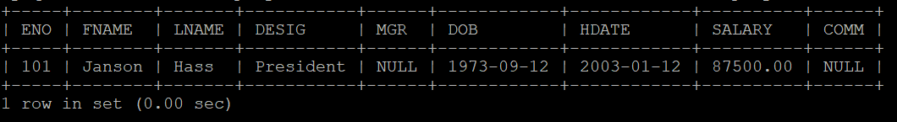
- List the details of employees who have been hired most recently as ‘salesman’.
SELECT * FROM employee WHERE HDATE = (SELECT MAX(HDATE) FROM employee WHERE DESIG = 'Salesman');
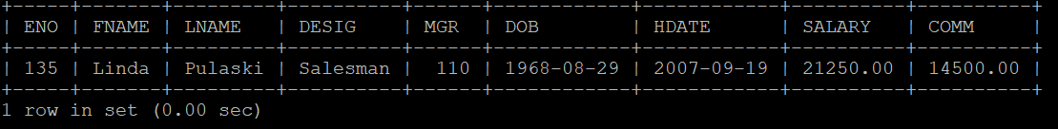
- List the employees who are senior to the most recently hired employees working under employee id 110.
SELECT * FROM employee WHERE HDATE < (SELECT MAX(HDATE) FROM employee WHERE MGR = 110);
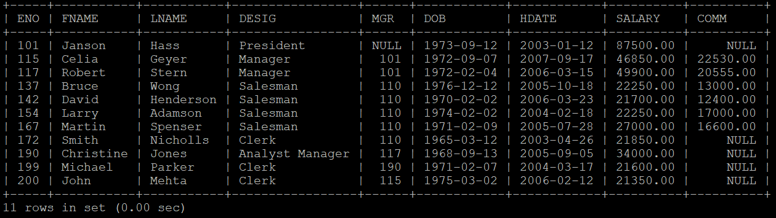
- Find and display the details of the senior employees as on year 1991.
SELECT * FROM employee WHERE DATEDIFF("1991-12-31", DOB) = (SELECT MAX(DATEDIFF("1991-12-31", DOB)) FROM employee WHERE YEAR(DOB) < 1991);
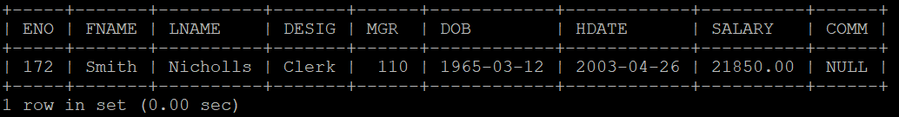
- List the employees’ names whose salary is equal or more to the average of maximum and minimum salary.

SELECT FNAME FROM employee WHERE SALARY >= (SELECT (MAX(SALARY) + MIN(SALARY))/2 FROM employee);
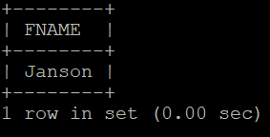
- Write a query to find and display the names of the least 5 earners of the company.
SELECT FNAME FROM employee ORDER BY SALARY LIMIT 5;
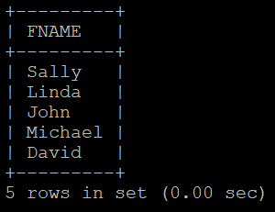
- List the name, salary, commission and netpay for those employees whose netpay (salary + commission) is more than any other employee.
SELECT FNAME, SALARY, COMM, SALARY + IFNULL(COMM, 0) AS "NETPAY" FROM employee WHERE SALARY + IFNULL(COMM, 0) = (SELECT MAX(SALARY + IFNULL(COMM, 0)) FROM employee);
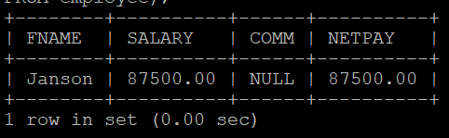
- Display the names of employees who joined the company on the same date.
SELECT FNAME FROM employee WHERE HDATE IN (SELECT HDATE FROM employee e GROUP BY HDATE HAVING e.HDATE = HDATE AND COUNT(*) > 1) ORDER BY HDATE;

- Display the employee numbers of employees who are not working under any managers.
SELECT ENO FROM employee WHERE MGR IS NULL;
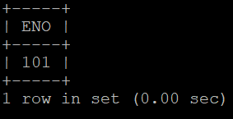
- List the names of the managers who are having maximum number of employees working under him.
SELECT M.FNAME, COUNT(*) FROM employee M, employee E WHERE M.ENO = E.MGR GROUP BY M.FNAME HAVING COUNT(*) = (SELECT MAX(mcount) FROM (SELECT COUNT(*) mcount FROM employee GROUP BY MGR) temp);
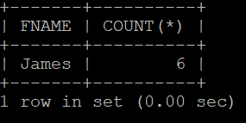
- Find and display the details of the most recently hired employees in each designation and order by hire_date.
SELECT * FROM employee WHERE (HDATE, DESIG) IN (SELECT MAX(HDATE), DESIG FROM employee GROUP BY DESIG) ORDER BY HDATE;
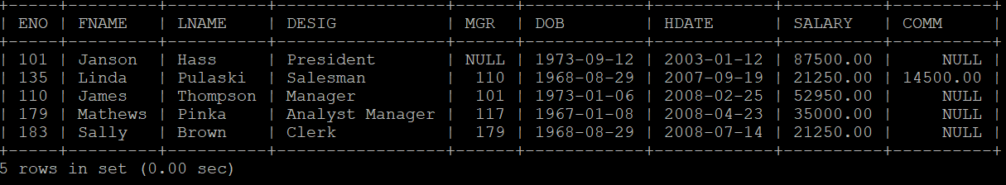
- Find the name and designation of the employees who earn a commission and salary is the maximum.
SELECT FNAME, DESIG FROM employee WHERE SALARY = (SELECT MAX(SALARY) FROM employee WHERE COMM IS NOT NULL) AND COMM IS NOT NULL;
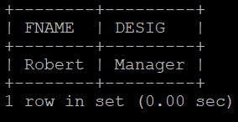
- List the details of employees who are getting same salary.
SELECT * FROM employee WHERE SALARY IN (SELECT SALARY FROM employee e GROUP BY SALARY HAVING e.SALARY = SALARY AND COUNT(*) > 1) ORDER BY SALARY;
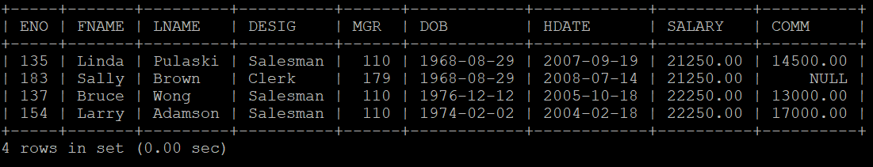
- Find and display the maximum of the average salary drawn for each designation except for President.
SELECT DESIG, AVG(SALARY) FROM employee GROUP BY DESIG;
OR
SELECT DESIG, AVG(SALARY) FROM employee WHERE DESIG!= 'President' GROUP BY DESIG ORDER BY AVG(SALARY);
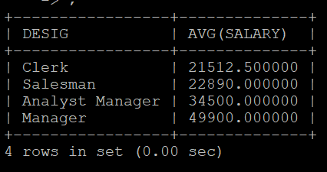
- Display the employee numbers of employees who are not managing other employees.
SELECT ENO FROM employee WHERE ENO NOT IN (SELECT A.ENO FROM employee A, employee B WHERE B.MGR = A.ENO);
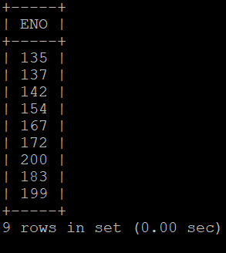
- Display the total remuneration (salary + commission) of all employees working under the manager number 110.
SELECT ENO, SALARY + IFNULL(COMM, 0) AS "TOTAL REMUNERATION" FROM employee WHERE MGR = 110;
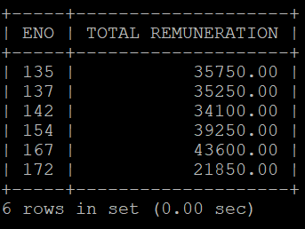
- Update the commission column with 10% increase in salary for the employees whose birthday falls in the current month.
UPDATE employee SET SALARY = 110 * SALARY / 100 WHERE MONTH(DOB) = MONTH(CURDATE());
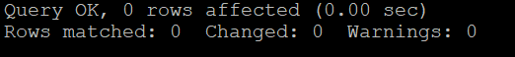
- Remove all the employees who are earning more than Rs. 40,000/- as their salary except ‘president’ and ‘manager’.
DELETE FROM employee WHERE SALARY > 40000.00 AND DESIG NOT IN ('President', 'Manager');

